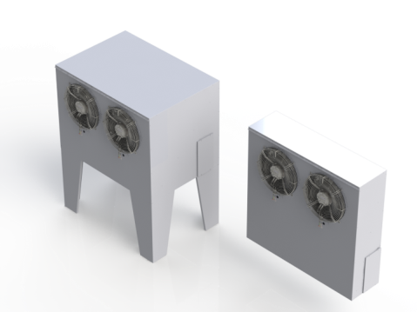**Air to Air Cold Climate Heat Pumps**

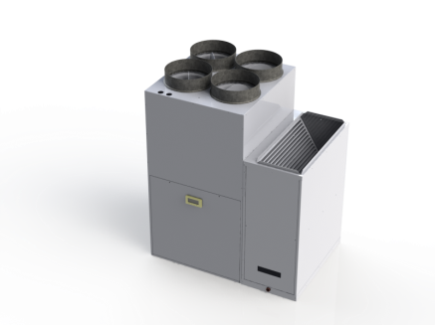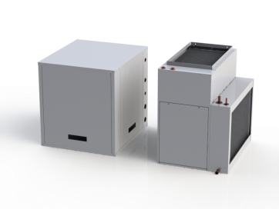

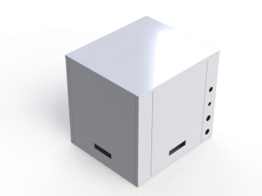

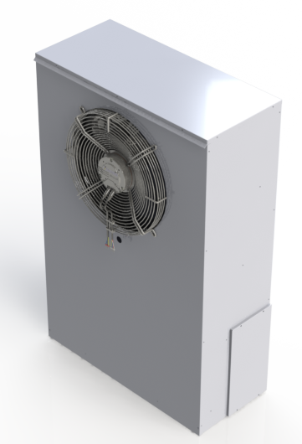

A2ASP200-2-LI-B with

ECHP200-HBU

A2A540-D-LI-B with

ECHP500-4-HBU

Outdoor units for 200 & 540 series

**PERFORMANCE SPECIFICATIONS**

|  |  |  |  |  |  |  |  |
| --- | --- | --- | --- | --- | --- | --- | --- |
|  | | **A2ASP200-2-LI-B** | | | **A2A540-D-LI-B** | | |
| **Outdoor Temp.** | | 8.3°C  (47°F) | -8.3°C  (17°F) | -25°C  (-13°F) | 8.3°C  (47°F) | -8.3°C  (17°F) | -25°C  (-13°F) |
| **Capacity (MBTU/hr)** | | 19.5 | 14.7 | 11.7 | 14.8 to  47.9 | 10.7 to  34.5 | 6.7 to  21.5 |
| **Capacity (kW)** | | 5.7 | 4.3 | 3.4 | 4.3 to  14.0 | 3.1 to  10.1 | 2.0 to  6.3 |
| **System COP** | | 2.9 | 2.4 | 1.8 | 3.2 | 2.7 | 2.2 |
| **HSPF Region 41** | | - | | | 9.2 | | |
| **HSPF Region 52** | | - | | | 8.4 | | |
| **Max. Air Flow** | | 800 cfm (377.6 L/s) | | | 1400 cfm (566.3 L/s) | | |
| **External Static** | | 0.5” WC | | | 0.5” to 1.5” WC | | |
| **Cooling Capacity** | **Tons** | 1.5 | | | 3.5 | | |
| **kW** | 5.3 | | | 14.1 | | |

**Note: Performance data subject to change. Please refer to latest version at time of purchase. Performance values based on 21.1°C return air temperature and maximum fan speed. Digital heat pump uses variable capacity compressor and will adjust as needed to meet demand. Capacity ranges shown are minimum and maximum at the rated outdoor air temperature.** **200 series is a two stage compressor with liquid injection. 500 series is digitally variable flow compressor with liquid injection. 1 to 4 zones. COP is rated maximum within published operating range.**

**1. For Northern USA and ARI 240/210-2008 Standard (Region 4). 2. For Canadian climate and Canadian Energy Star (Region 5).**

**PHYSICAL SPECIFICATIONS**

| **Indoor Heat Pump** | **A2ASP200-2-LI-B** | **A2A540-D-LI-B** |
| --- | --- | --- |
| **Voltage (V/PH/Hz)** | 230/1/60 | 230/1/60 |
| **Compressor LRA** | 90 | 134 |
| **Minimum Circuit Ampacity (A)** | 24 | 42 |
| **Maximum Fuse size (A)** | 30 | 70 |
| **Weight – Indoor Unit (pounds)** | 90 | 180 |
| **Indoor Comp. Cabinet Dim(W x D x H)** | 22” x 25” x 24” | 25” x 30” x 30” |
| **Liquid Line Size O.D. (inches)** | 3/8 | 5/8 |
| **Vapour Line Size O.D. (inches)** | 5/8 | 7/8 |
| **Domestic Assist conn (inches)** | 1/ 2 | 1/ 2 |
| **Factory Refrig. Charge (ounces)** | 45 | 100 |

| **Heat Pump air Handler** | **ECHP200-HBU** | **ECHP500-x-HBU** |
| --- | --- | --- |
| Dimensions, single zone (W x D x H) inches | 14x25x26 | 23x25x32 |
| Dimensions, multi zone (W x D x H) inches | 14x25x36 | 23x25x42 |
| Supply Air single zone (WxD) inches | 12”x20” | 20”x20” |
| Supply Air multi zone (WxD) inches | 2@10”Ø | 4@10”Ø |
| Return Air (WxD) inches | 14”x23” | 18”x23” |
| Filter Rack Size (WxD) inches | 16”x25” | 20”x25” |
| Water inlet and outlet | ½” | ¾” |
| Back up coil size (length x width - rows) | 13x20-2R | 22x20-2R |
| Shipping weight – pounds | 60 | 88 |
| Power (Volts/Phase/Hz) | 115/1/60 | 230/1/60 |
| Total Unit FLA | 6.3 | 6.0 |
| Minimum Ampacity | 7.7 | 8.0 |
| Max over current (fuse size) Amps | 15 | 15 |
| Motor Horsepower | 1 /3 | 3 /4 |
| Blower Model | 10x5 | 10x10 |
| Cased Coil Dimensions(W x D x H) inches | 5x25x18 | 10x25x30 |

|  |
| --- |
|  |
|  |
|  |

**Air to Water Cold Climate Heat Pumps**

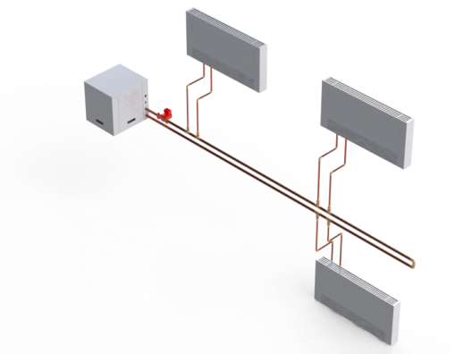

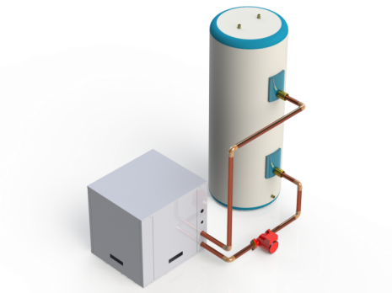

A2W600-2-LI-B connected to Thermal Storage tank

A2W540-D-LI-B direct connected to loads through primary loop

**PERFORMANCE SPECIFICATIONS**

|  |  |  |  |  |  |  |  |  |  |  |  |  |  |
| --- | --- | --- | --- | --- | --- | --- | --- | --- | --- | --- | --- | --- | --- |
|  | | A2W540-D-LI-B | | | | | | A2W600-2-LI-B | | | | | |
| * 4-1/2 Ton digital compressor * Liquid injection * Thermal Storage Optional | | | | | | * 5 Ton two-stage compressor * Liquid injection * Thermal Storage Required (field supplied) | | | | | |
| **Outdoor Temp.** | | 8.3°C (47°F) | | -8.3°C (17°F) | | -25°C (-13°F) | | 8.3°C (47°F) | | -8.3°C (17°F) | | -25°C (-13°F) | |
| **Inlet Load Temp.** | | 30°C  (86°F) | 40°C (104°F) | 30°C (86°F) | 40°C (104°F) | 30°C (86°F) | 40°C (104°F) | 30°C (86°F) | 40°C (104°F) | 30°C (86°F) | 40°C (104°F) | 30°C (86°F) | 40°C (104°F) |
| **Capacity (MBTU/hr.)** | | 14.7  to  47.5 | 13.4  to  43.2 | 10.8  to  34.7 | 8.8  to  28.6 | 6.9  to  22.2 | 6.0  to  19.3 | 48.0 | 41.8 | 36.8 | 32.0 | 25.0 | 21.8 |
| **Capacity (kW)** | | 4.3 to  13.9 | 3.9  to  12.7 | 3.2  to  10.2 | 2.6  to  8.4 | 2.0  to  6.5 | 1.8  to  5.7 | 14.1 | 12.3 | 10.8 | 9.4 | 7.3 | 6.4 |
| **Heat Pump COP3** | | 3.7 | 2.7 | 3.0 | 2.0 | 2.5 | 1.8 | 3.3 | 2.3 | 2.9 | 2.0 | 2.1 | 1.5 |
| **Cooling Capacity** | **Tons** | 4 | | | | | | 4 | | | | | |
| **kW** | 14 | | | | | | 14 | | | | | |

**Notes : Performance data subject to change. Performance based on load-side water flow rate of 12 gpm.**

**1. Digital Heat pump uses variable capacity compressor and will adjust as needed to meet demand. Capacity ranges shown are minimum and maximum at the rated outdoor air temperature. Tank not included.**

**2. Two stage Heat pump uses two-stage compressor and will adjust based on demand. Capacities shown are for second stage. First stage capacities are approximately 2/3 of the values given. Tank not included.**

**3. Rated maximum COP within published operating range. Excludes pump power.**

**PHYSICAL SPECIFICATIONS**

|  |  |  |
| --- | --- | --- |
|  | **A2W540-D-LI-B** | **A2W600-2-LI-B** |
| **Voltage (V/PH/Hz)** | 230/1/60 | 230/1/60 |
| **Compressor LRA** | 134.0 | 179.2 |
| **Minimum Circuit Ampacity (A)** | 37 | 43 |
| **Maximum Fuse size** | 60 | 70 |
| **Weight – Indoor Unit (pounds)** | 240 | 238 |
| **Indoor Cabinet Dim(W x D x H)** | 25” x 30” x 30” | 25” x 30” x 30” |
| **Liquid Line Size O.D. (inches)** | 5/8 | 5/8 |
| **Vapour Line Size O.D. (inches)** | 7/8 | 7/8 |
| **Domestic Assist HX plumbing (inches)** | ½ | ½ |
| **Factory Refrigerant Charge (ounces)** | 45 | 52 |

|  |
| --- |
|  |

|  |
| --- |
|  |

**Outdoor Modules**

|  |  |  |
| --- | --- | --- |
| **Models** | | |
| **OD-200-WM** | **OD-500-SA** | **OD-500-WM** |
|  |  |  |
| * Wall-mount module for 200 series heat pumps | * Stand-alone module for 500 and 600 series heat pumps | * Wall-mount module for 500 and 600 series heat pumps |
| 27.25" x 12" x 42" (W x D x H) | 43.25” x 30” x 56” (W x D x H) | 43.25” x 12” x 42” (W x D x H) |

**Note: Dimensions subject to change. Please refer to latest version at time of purchase.**