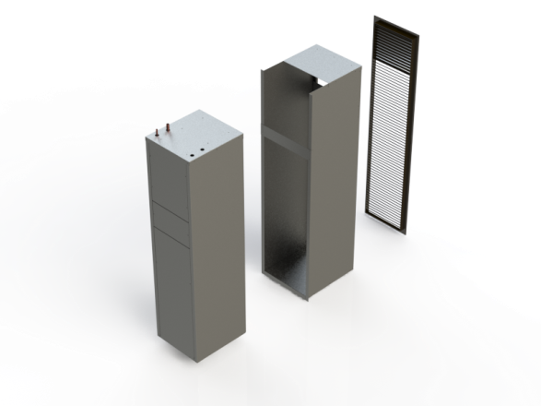**TW 18**

**1.5 Ton wall sleeve condensing unit**

* Insulated for sound attenuation
* Installed and serviced from the indoors
* 208 / 230V single phase
* G90 Galvanized for long rust free life

|  |  |  |  |  |  |  |  |  |  |
| --- | --- | --- | --- | --- | --- | --- | --- | --- | --- |
| Catalogue No. | Capacity (Tons) | Cabinet dimensions (inches) | | | RefrigerantLine size | | Electrical | | Compressor  Type |
| Width | Height | Depth | Liquid | Vapor | Min Amps | Max Breaker Amps |
| TW18 | 1.5 | 14.25 | 56 | 16 | 3/8” | 5/8” | 12 | 20 | Scroll |

Print Date:10/5/2014

|  |  |
| --- | --- |
| **Project** |  |
| **Address** |  |
| **Date** |  |